**Project**

**Joe’s Pizza Portal**

**Aim:**

To create a Prototype for Joe’s Pizza Portal Using NUnit, and SpecFlow to Develop and Test. Deploy it into Azure VM Using Jenkins.

**GitHub Link:**

[**https://github.com/Sukirthalakshmanan1/PizzaHub1**](https://github.com/Sukirthalakshmanan1/PizzaHub1)

**Procedure:**

* Create an ASP.NET core web application.
* Create cart and product controller and write necessary properties.
* In Home page all pizza are dispalyed
* Initially the cart is empty and select the pizza and add to cart
* Create model cart,product.
* Create views Cart ,paypal partial.cshtml
* On viewing the cart item can be added and removed
* The products can be added and can be removed.
* And to checkout the pizza it redirects to Paypal
* Create Nunit Test and check the testcases passed or failed
* Create a project Specflow and write the procedure and step definitions.
* Open Test explorer and check the Testcases passed or failed.
* After the Application runs push it to GitHub repository
* Open Jenkins and create new item -> free style project and click ok.
* Go to configure and go to Github repository and paste the Github link
* And write your credentials
* Save and build
* After successful build go to configure and and add visual studio
* And copy the msbuild path and paste and save
* Build now
* On successful build Console Output is shown.

**Azure Site URL:**

[**https://pizzahub20221103195752.azurewebsites.net**](https://pizzahub20221103195752.azurewebsites.net)

**Output:**

**Home Page:**

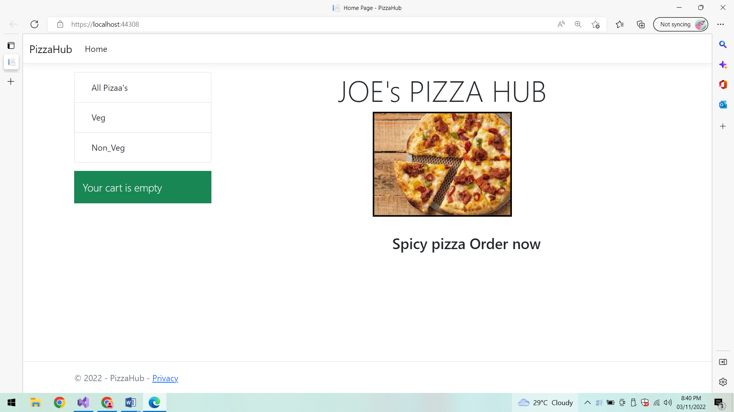

**Cart is Empty:**

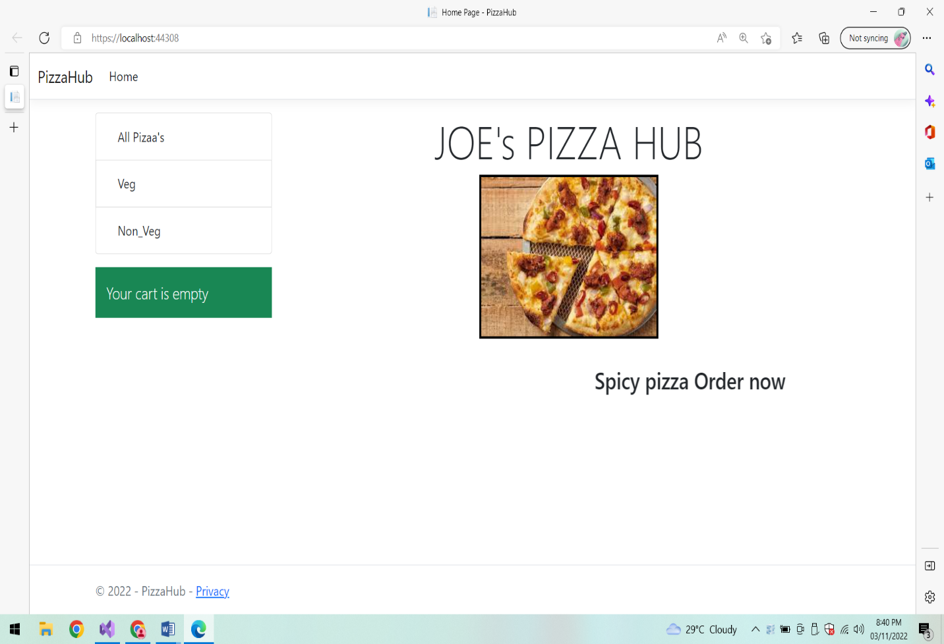

**All Pizza:**

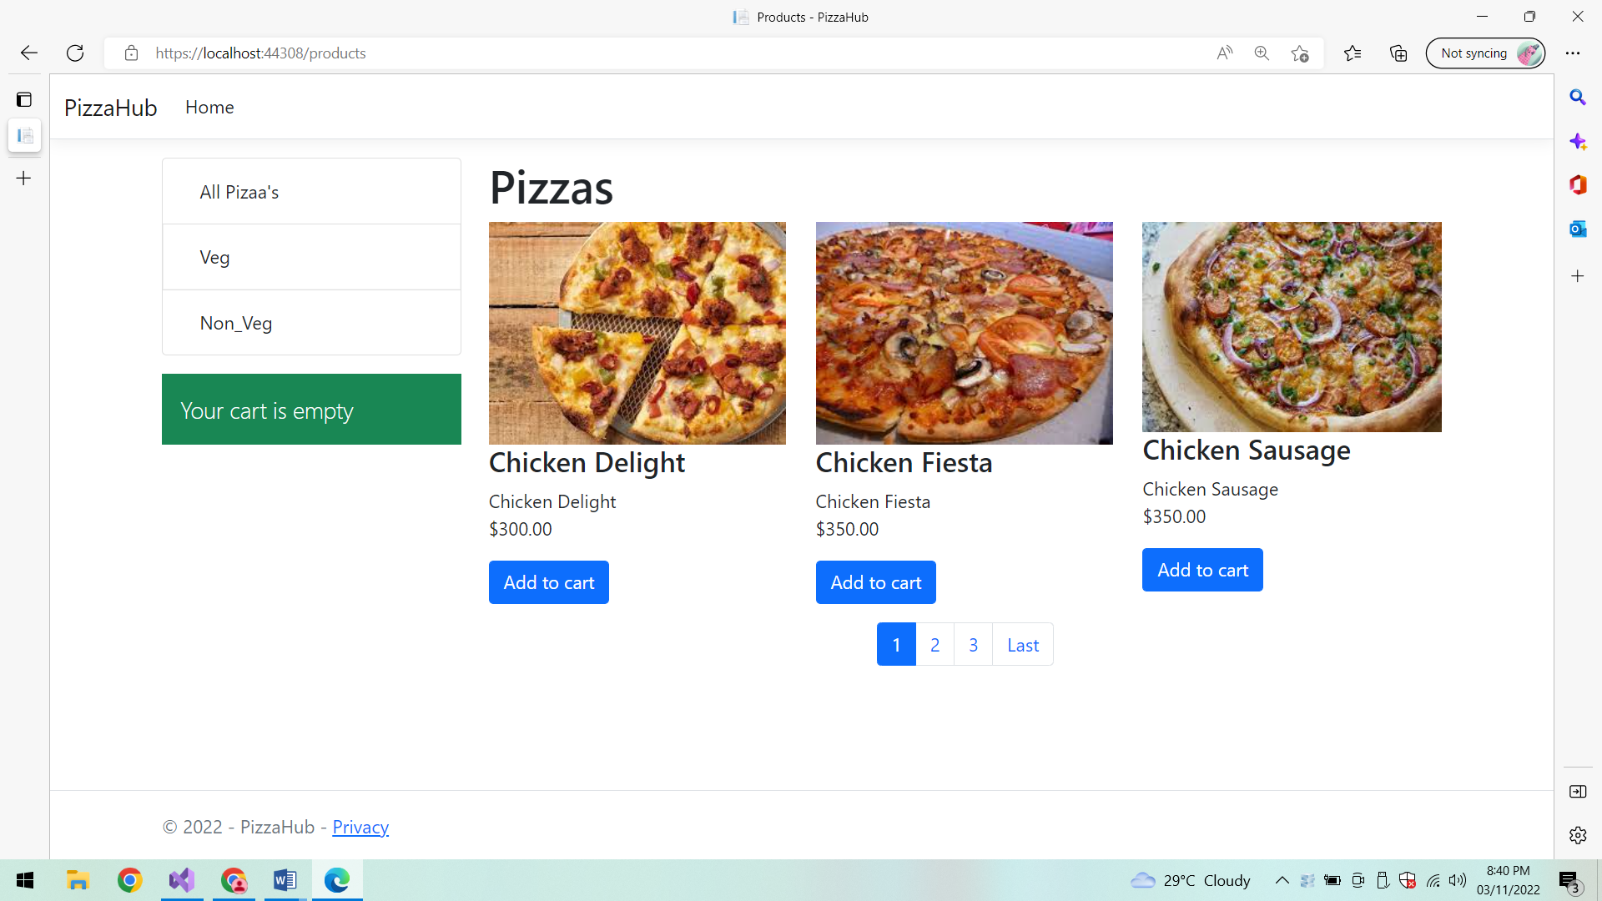

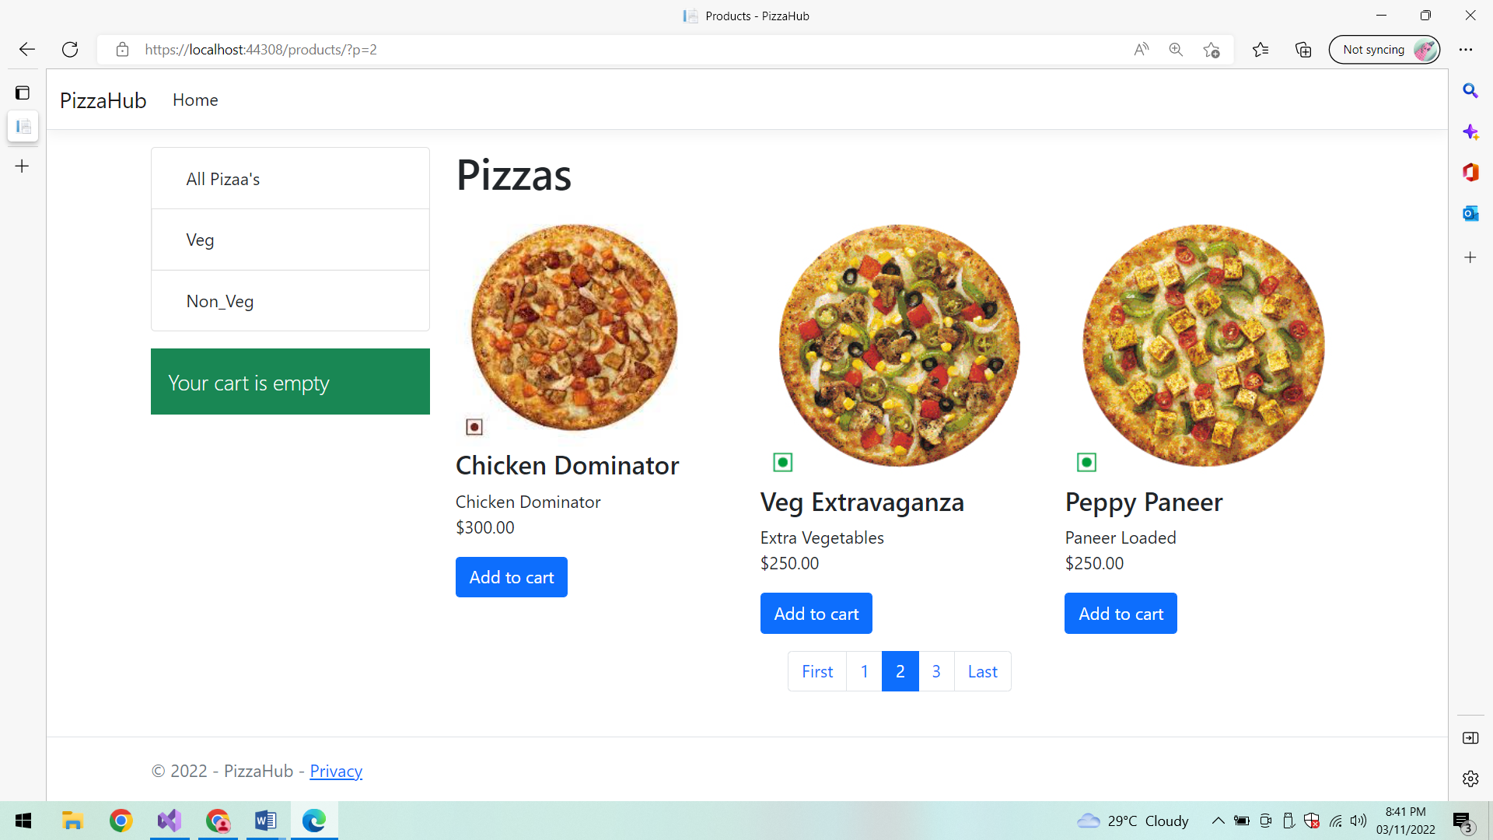

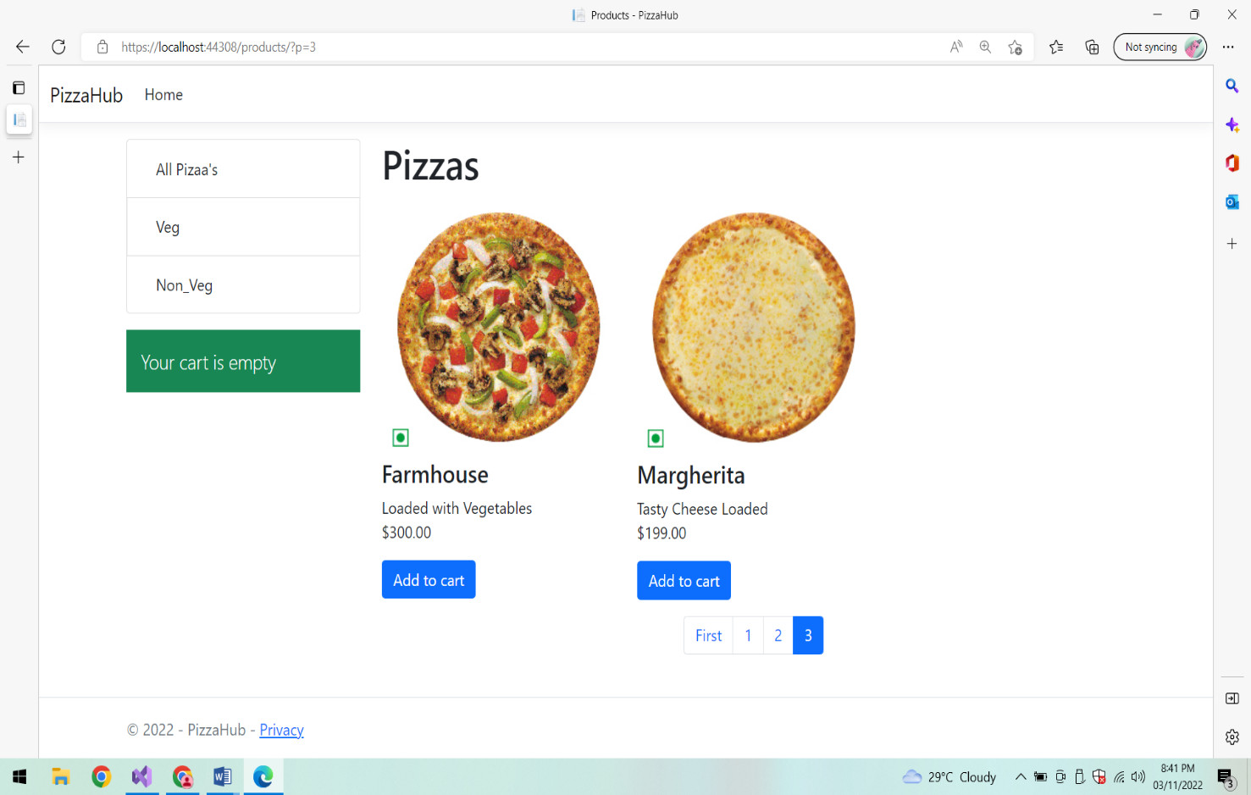

**Veg Pizza:**

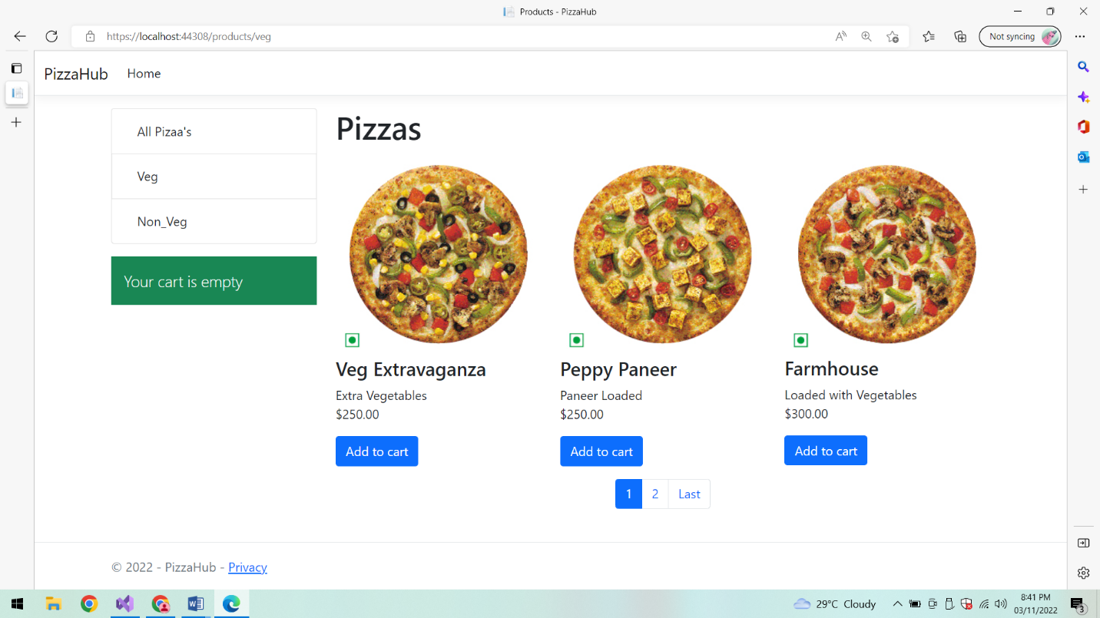

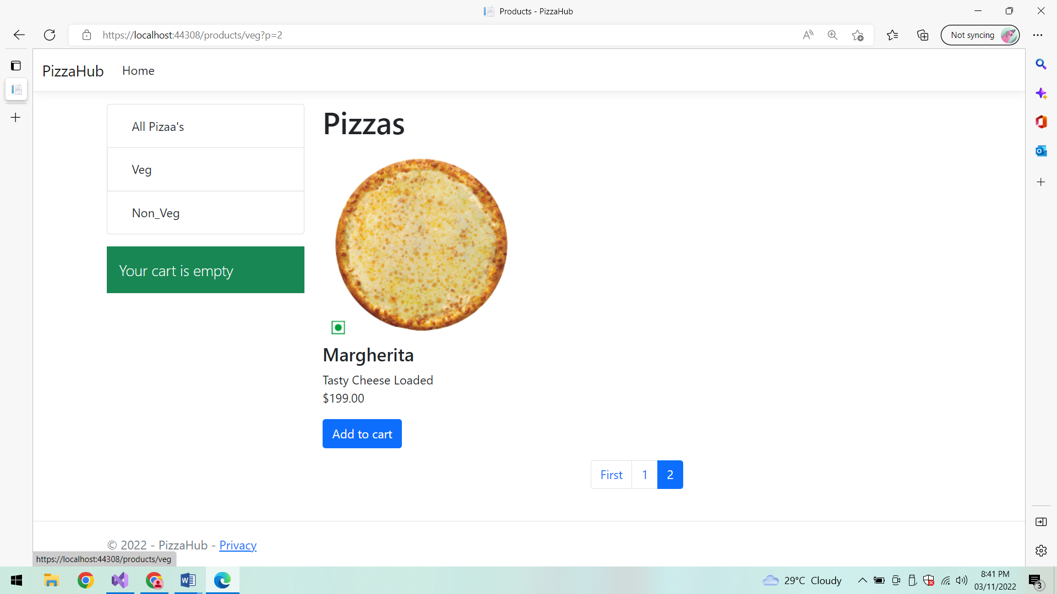

**Non Veg Pizza:**

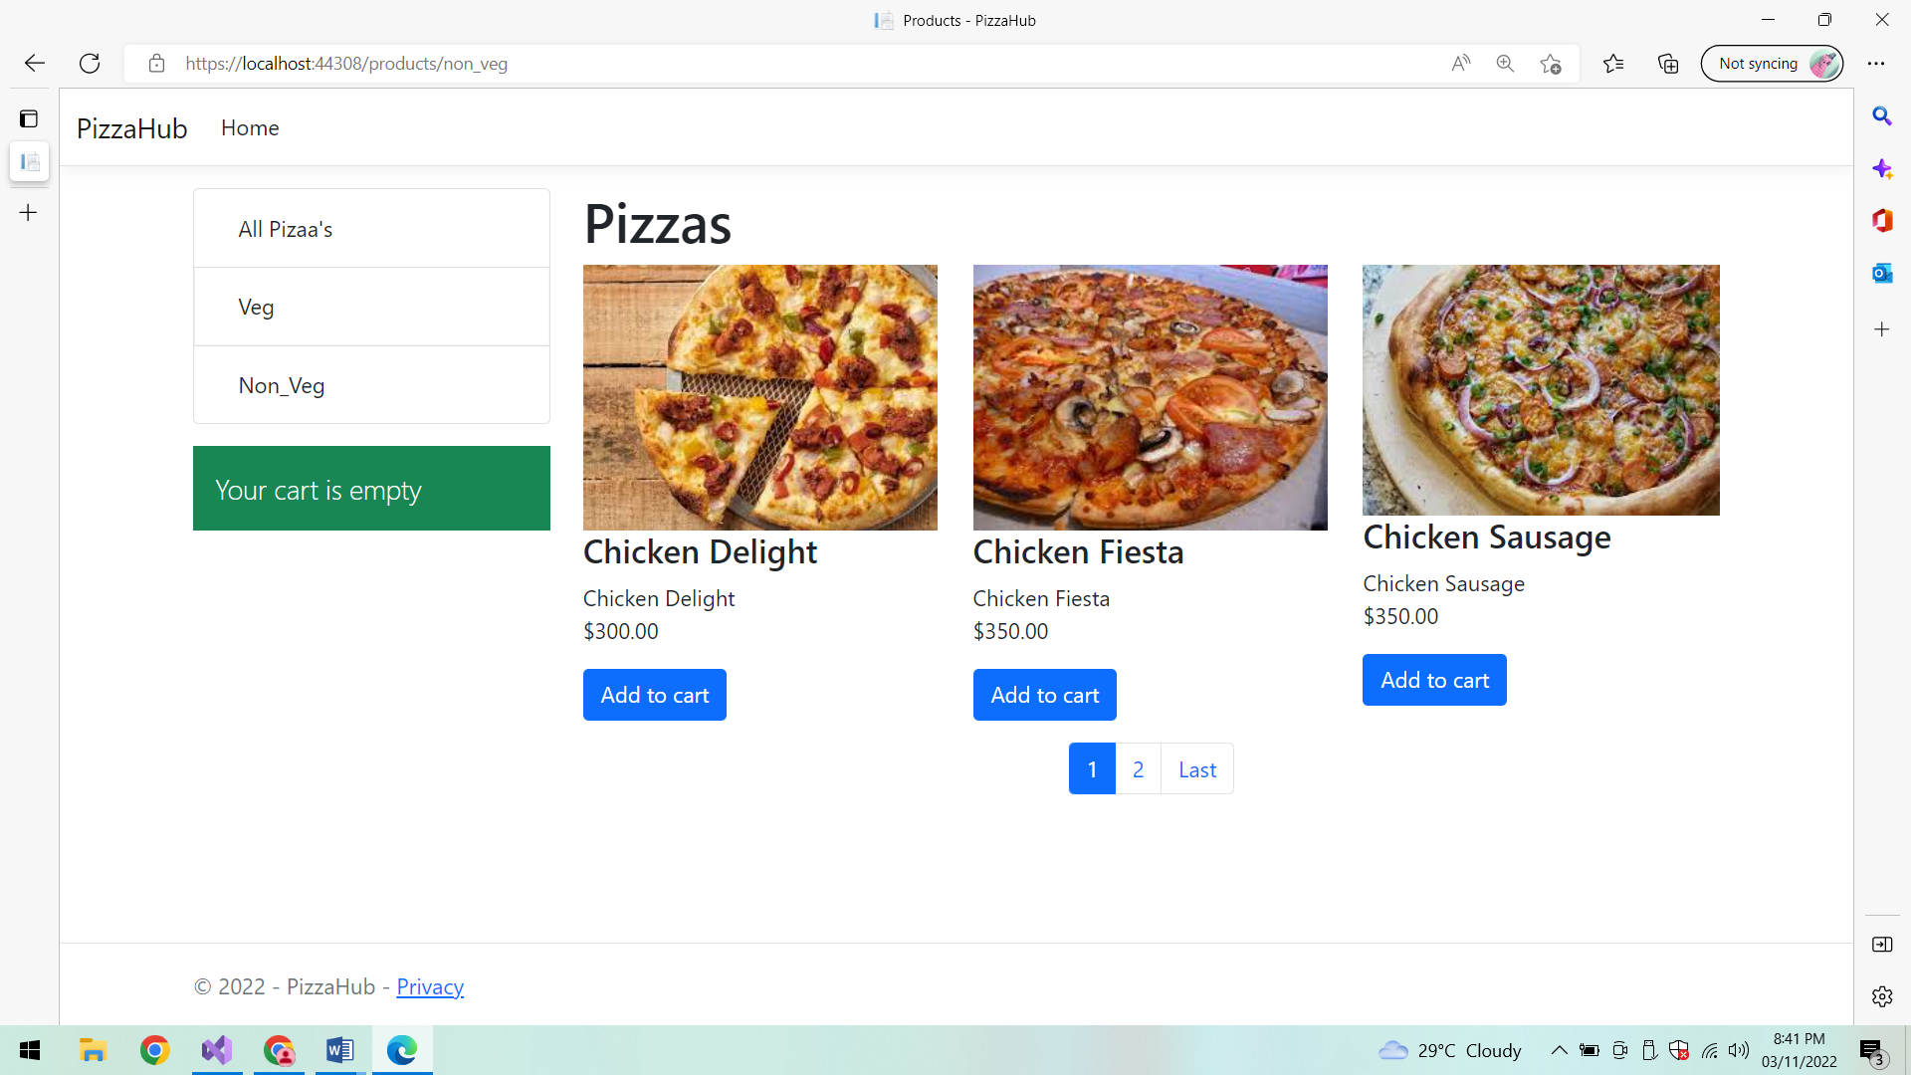

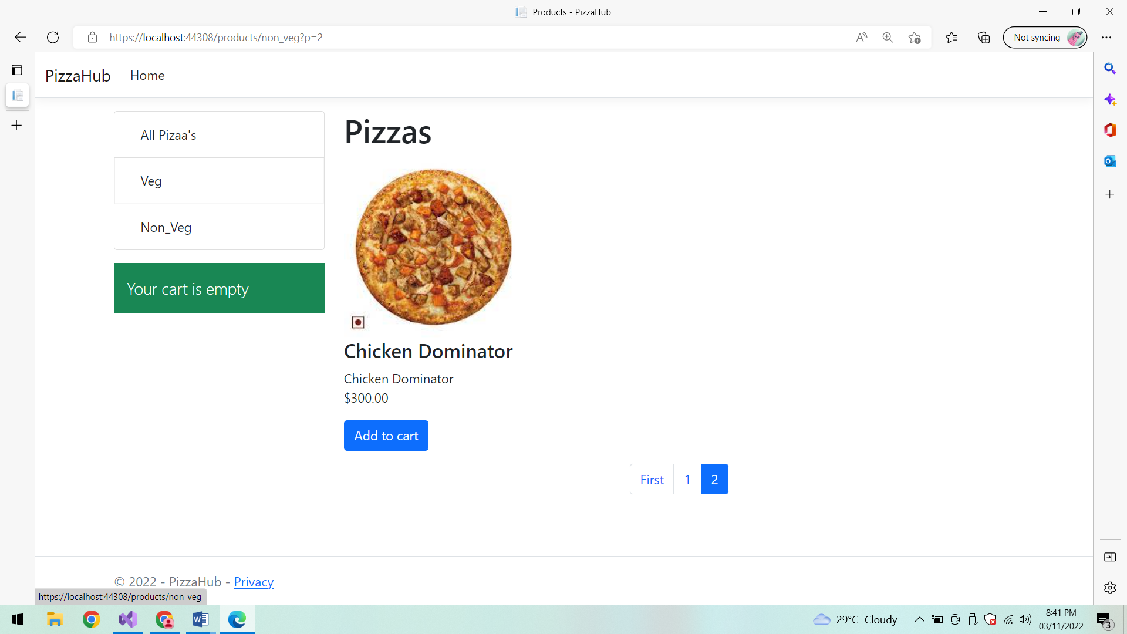

**Add to Cart:**

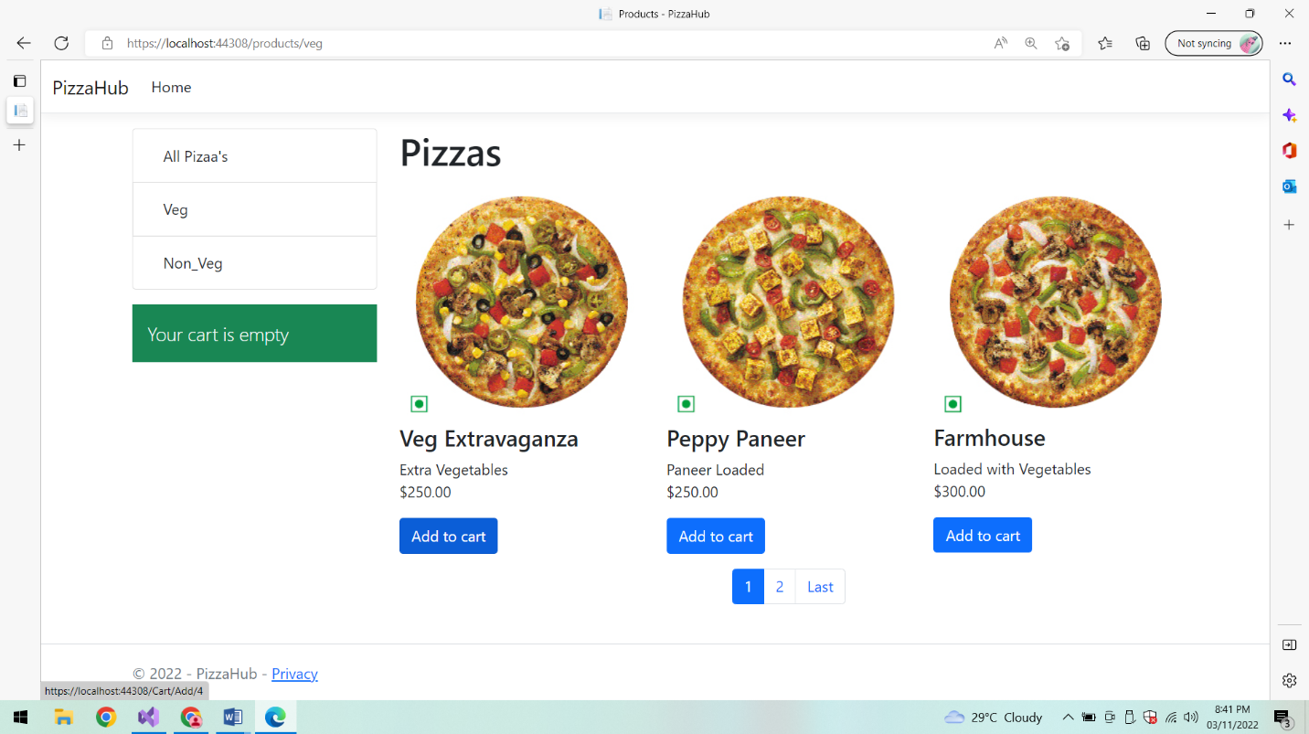

**Items in Cart:**

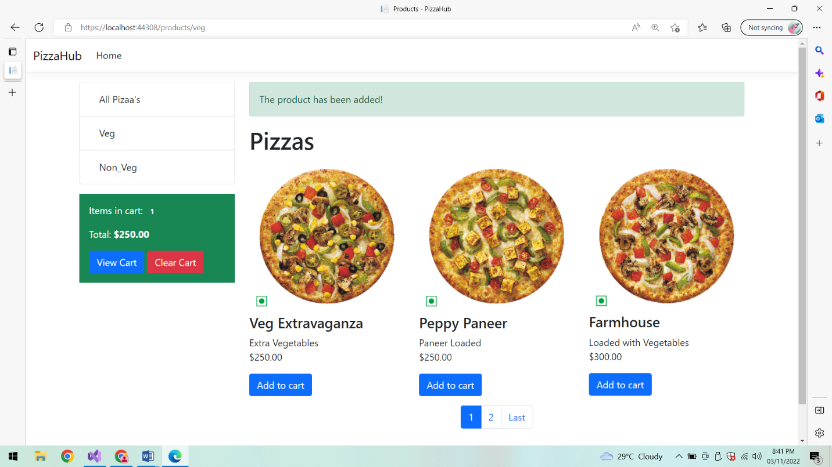

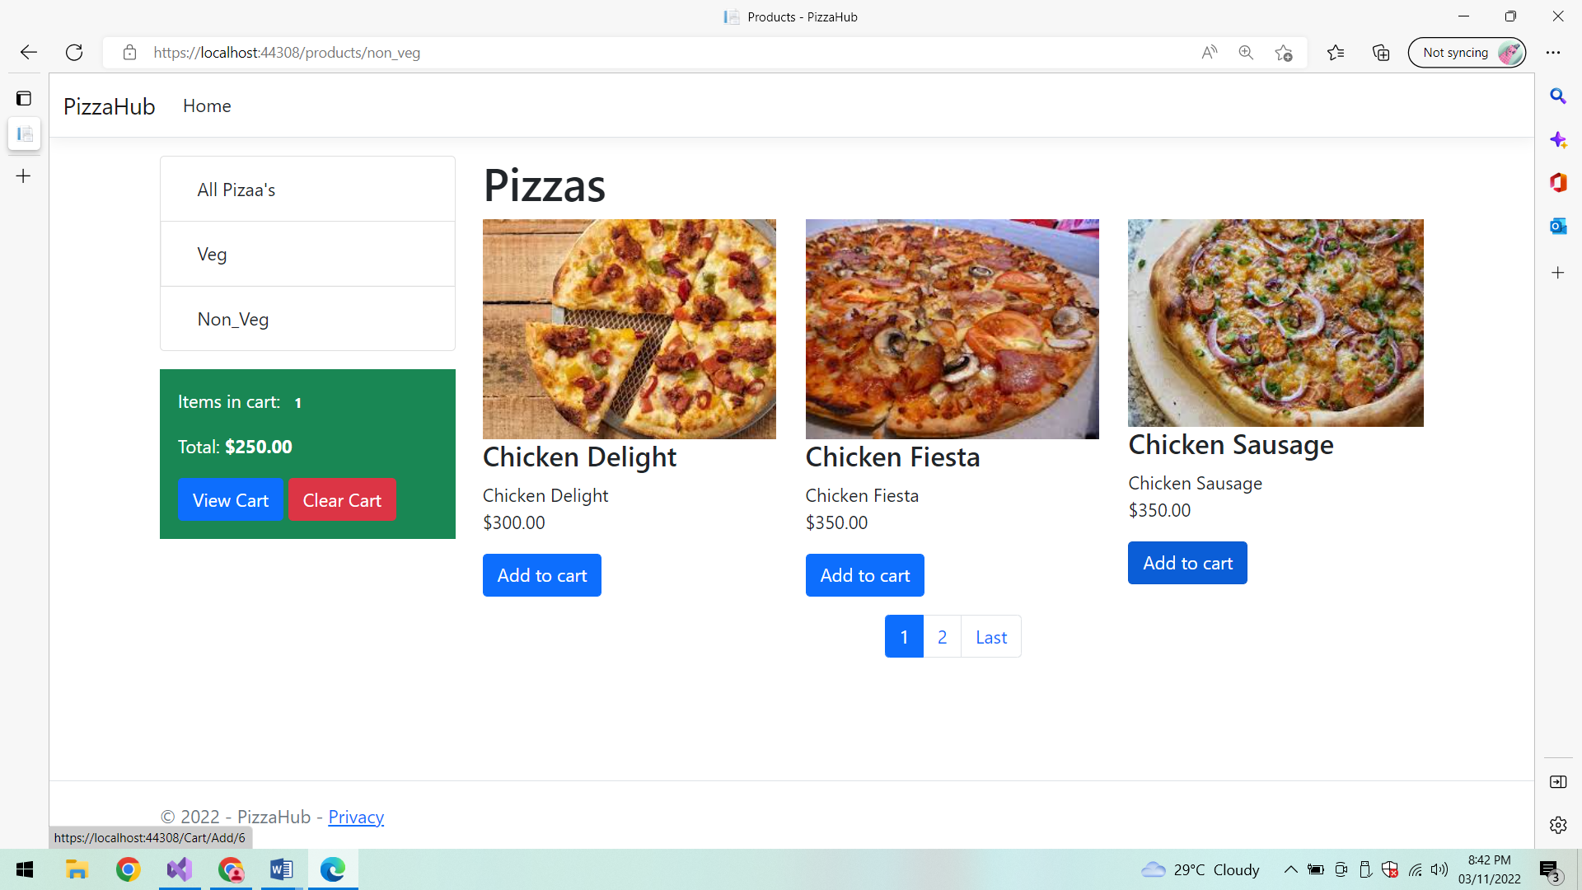

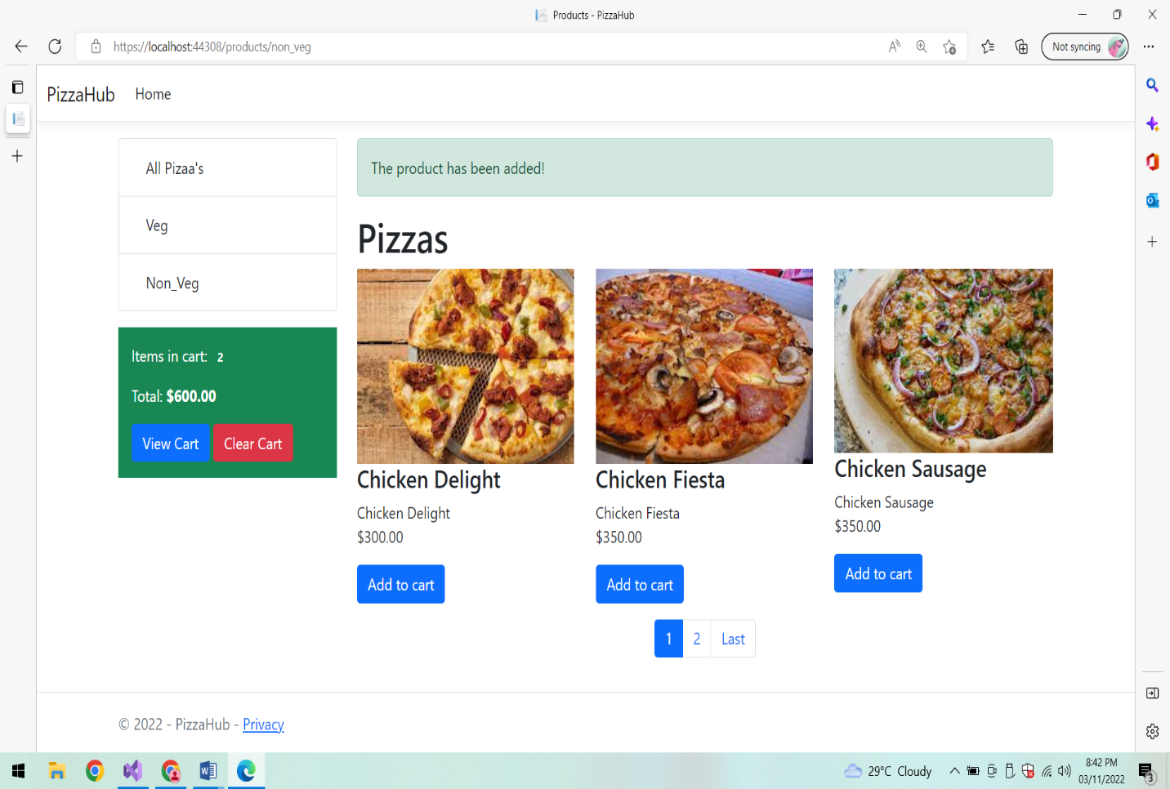

**Add Item:**

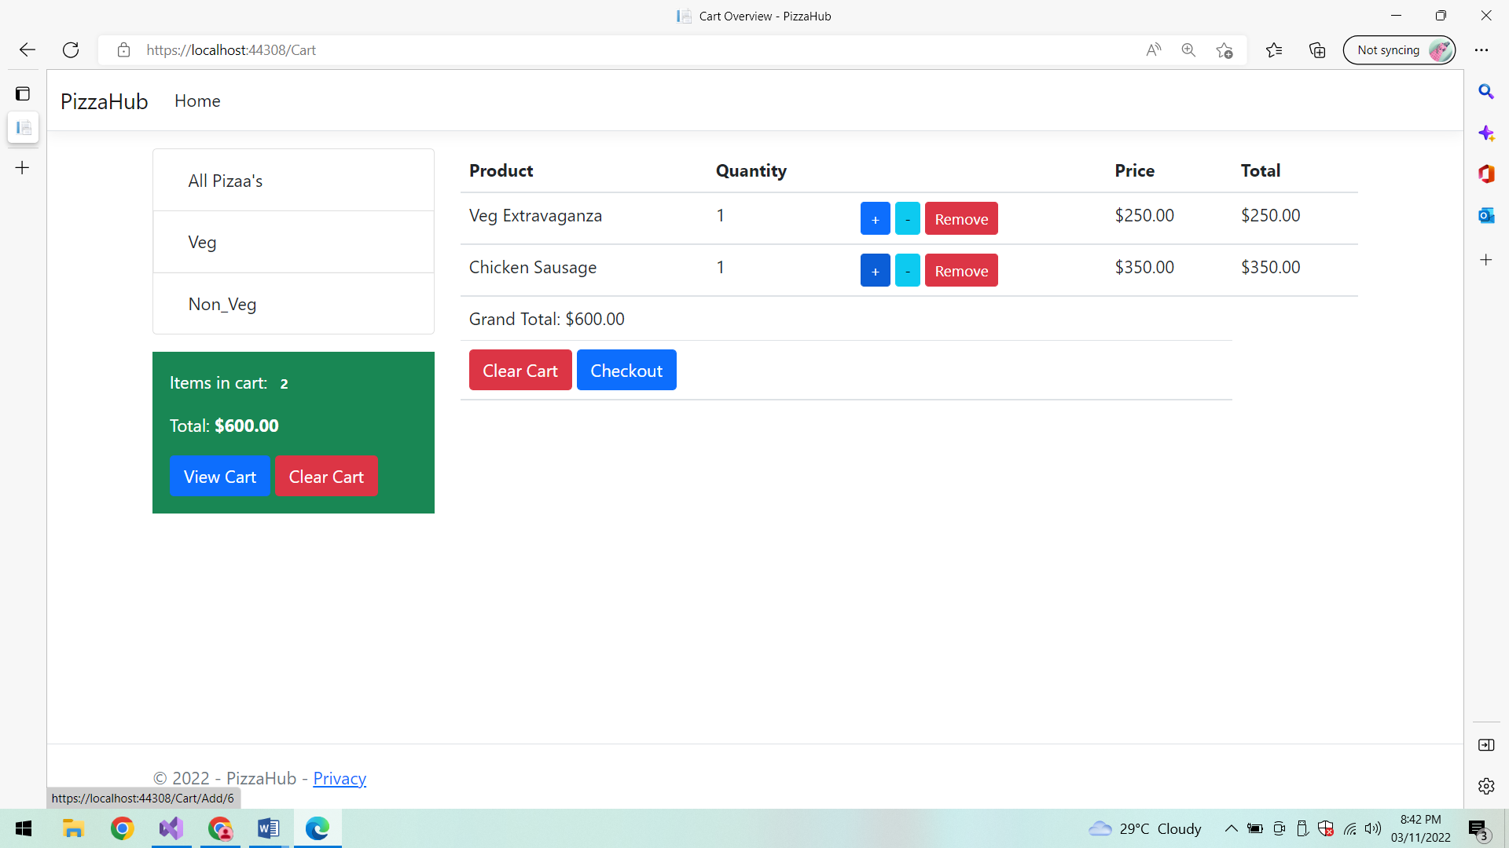

**Product added:**

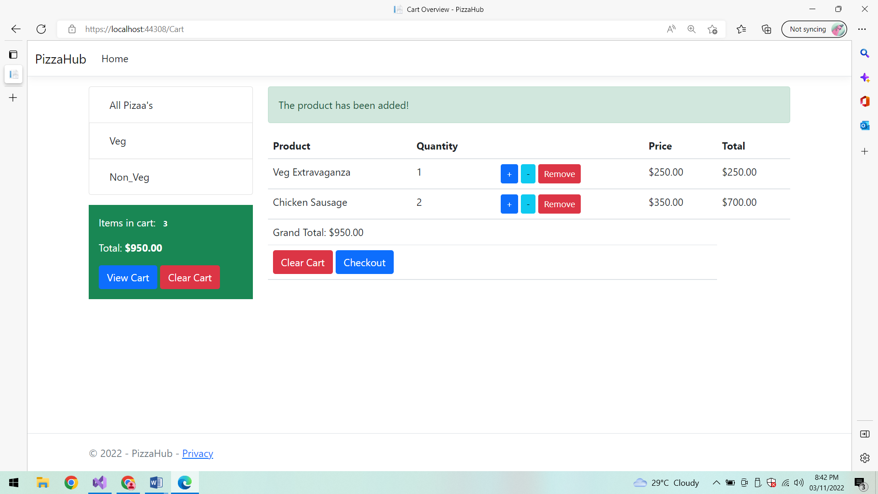

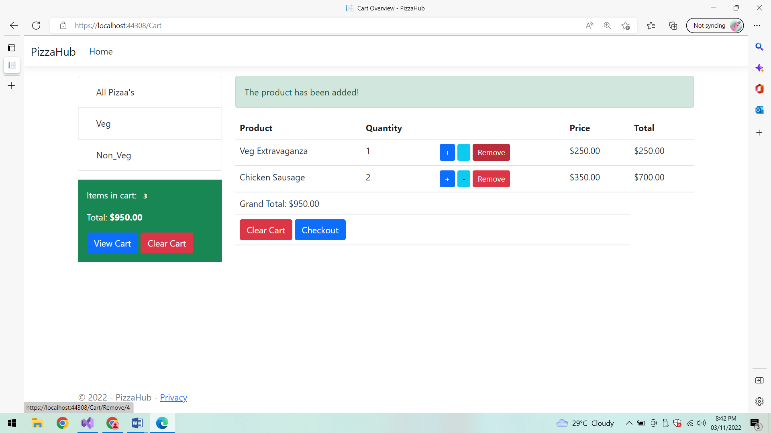

**Product Removed:**

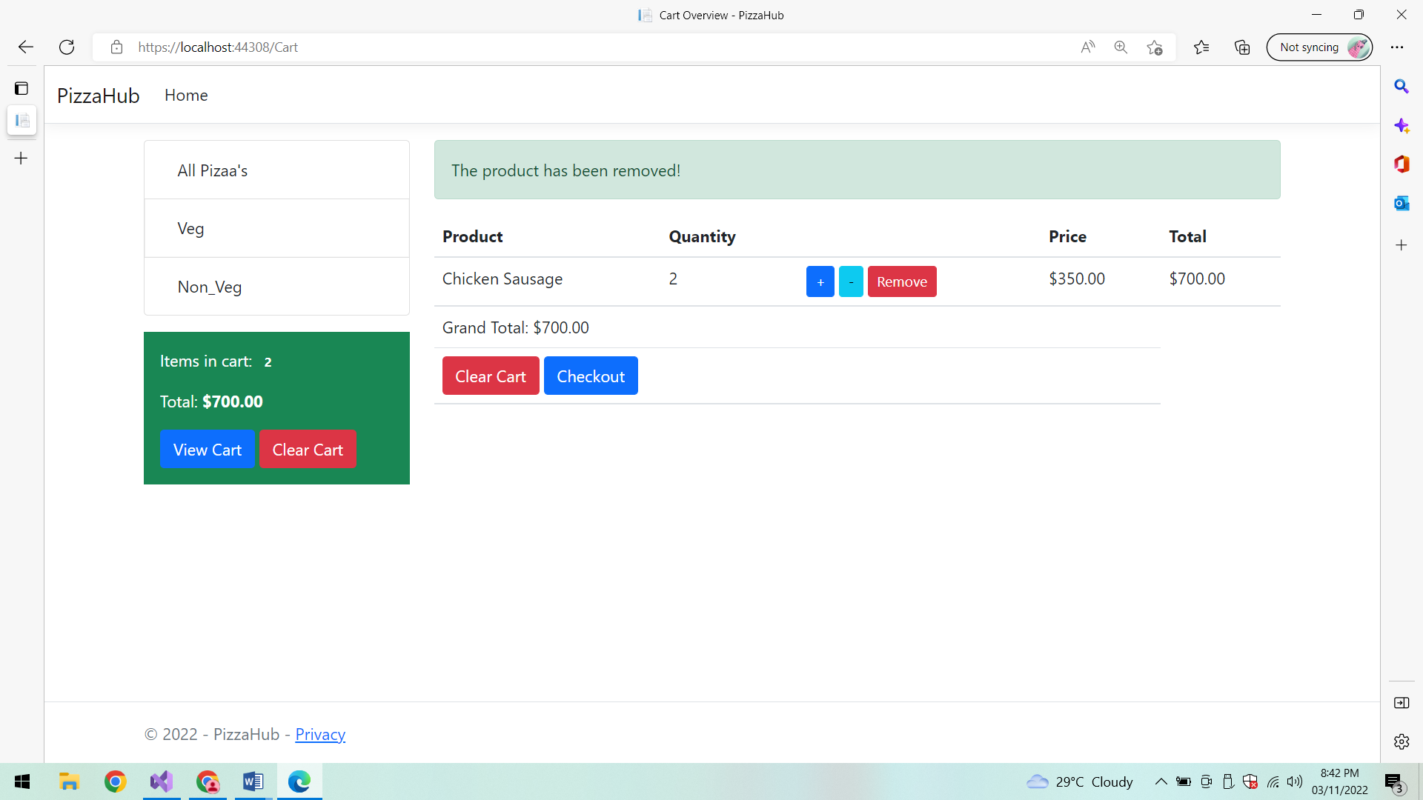

**Check out:**

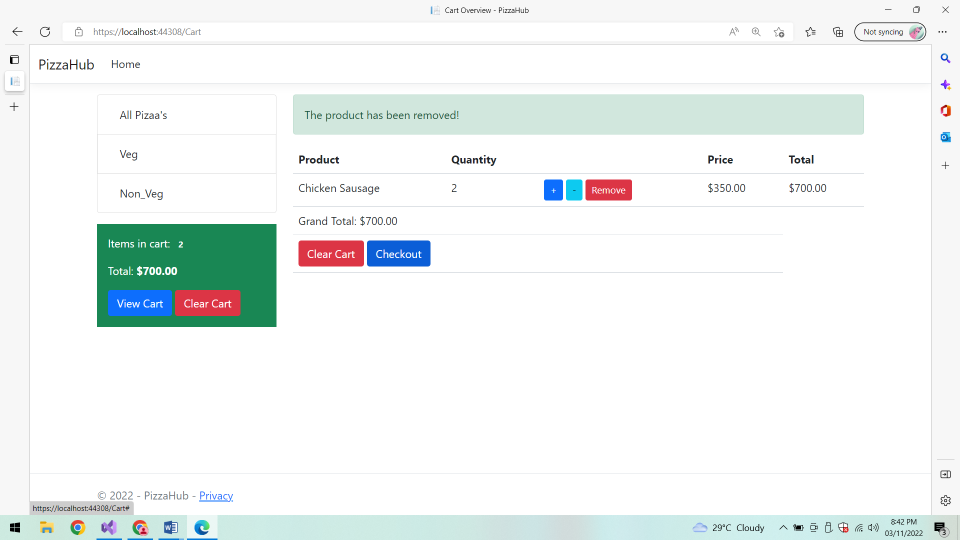

**Redirecting to Paypal:**

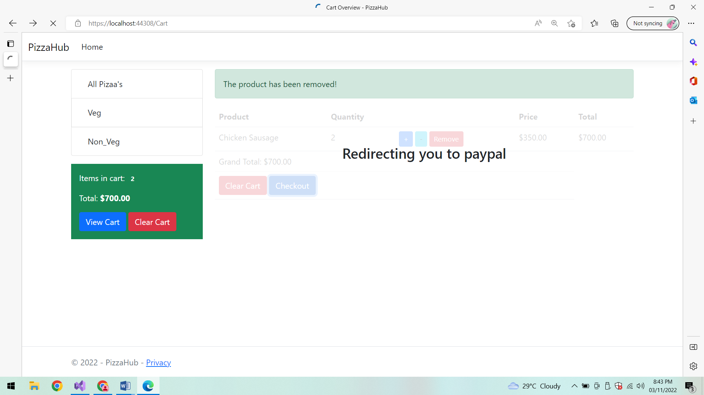

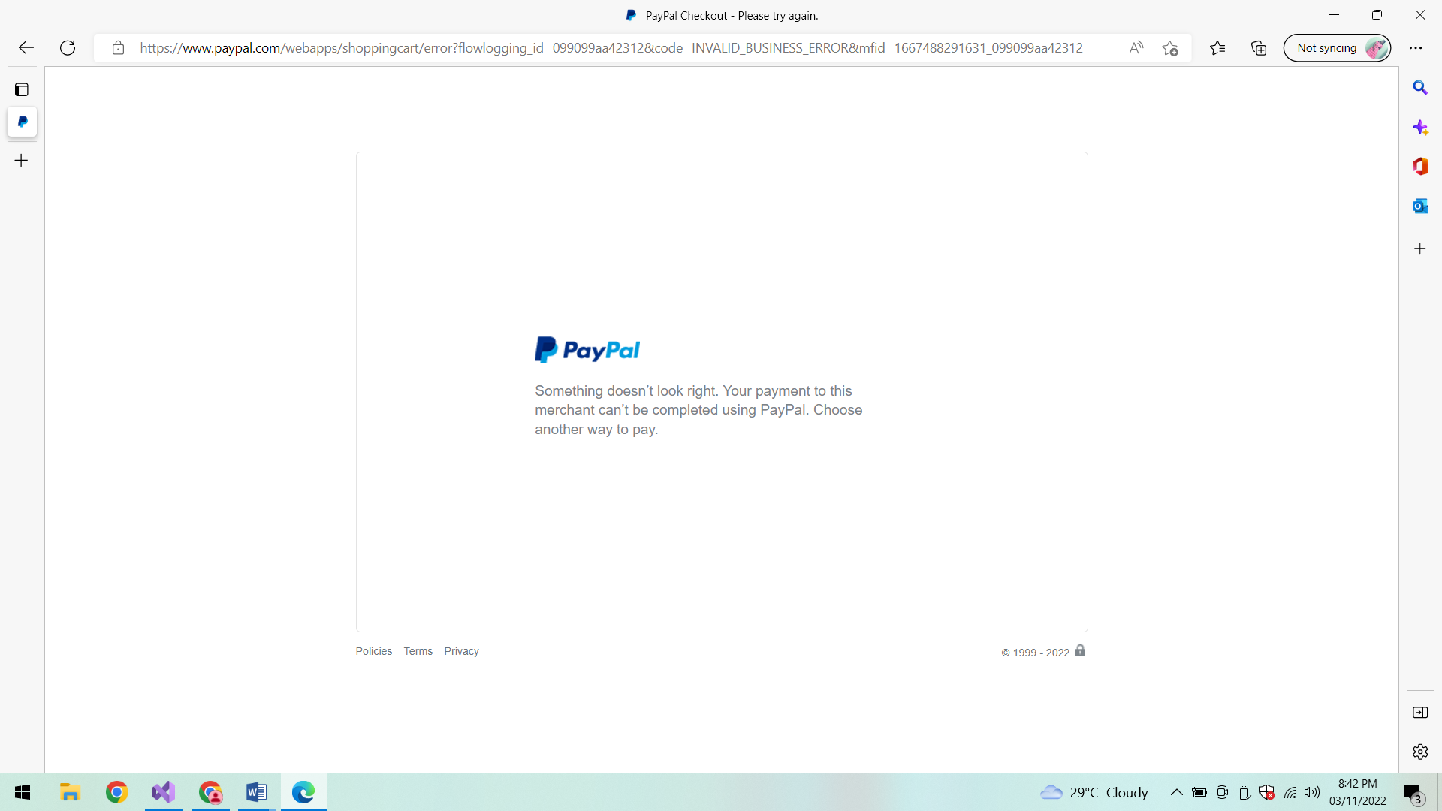

**Clear cart:**

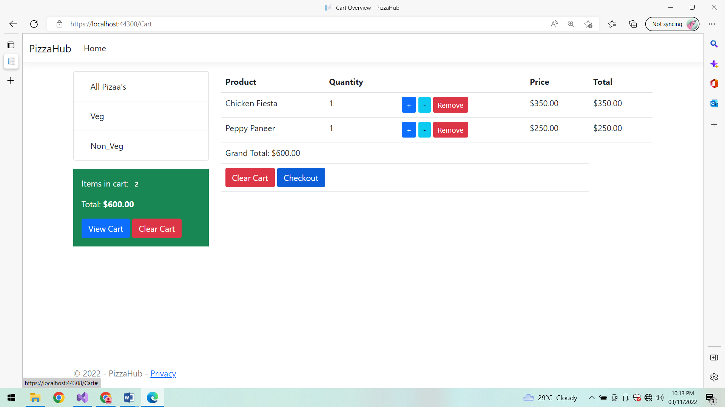

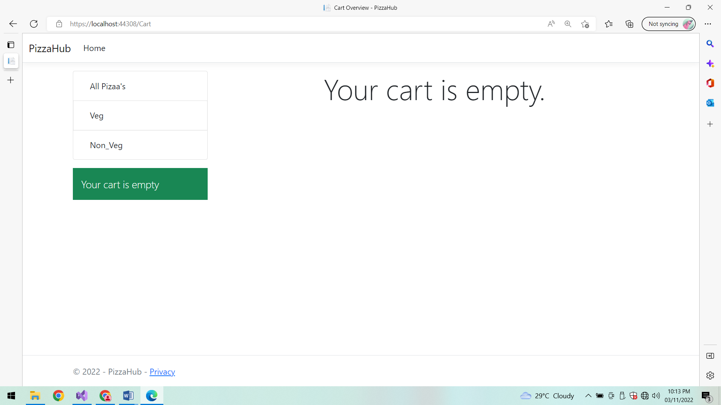

**Specflow:**

**Test Case:**

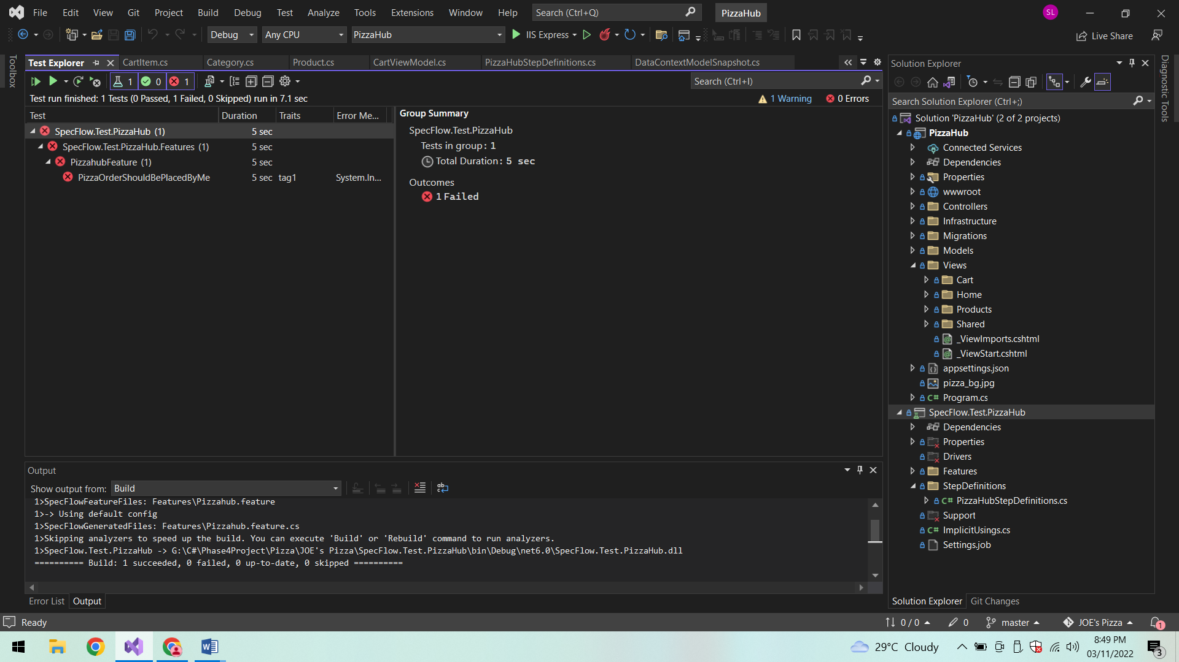

**Azure:**

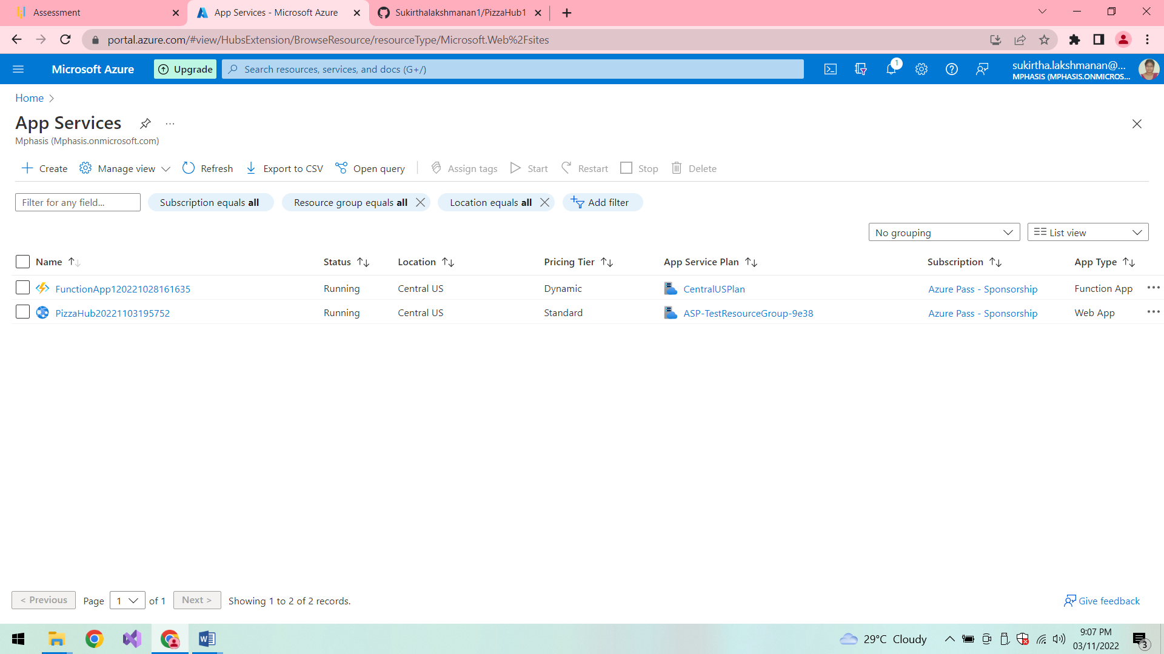

**Jenkins:**

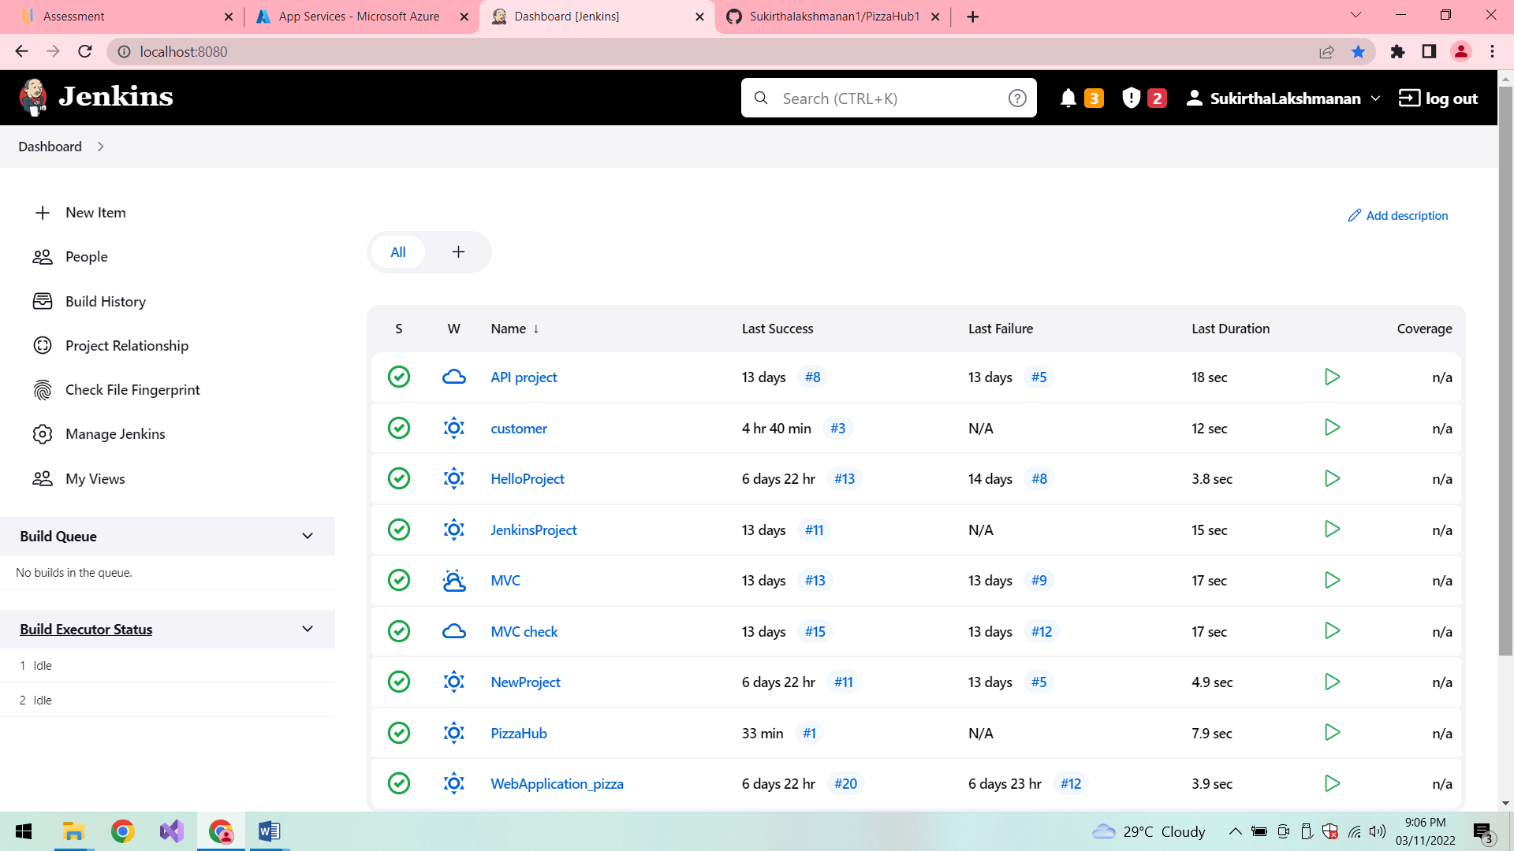

**Build:**

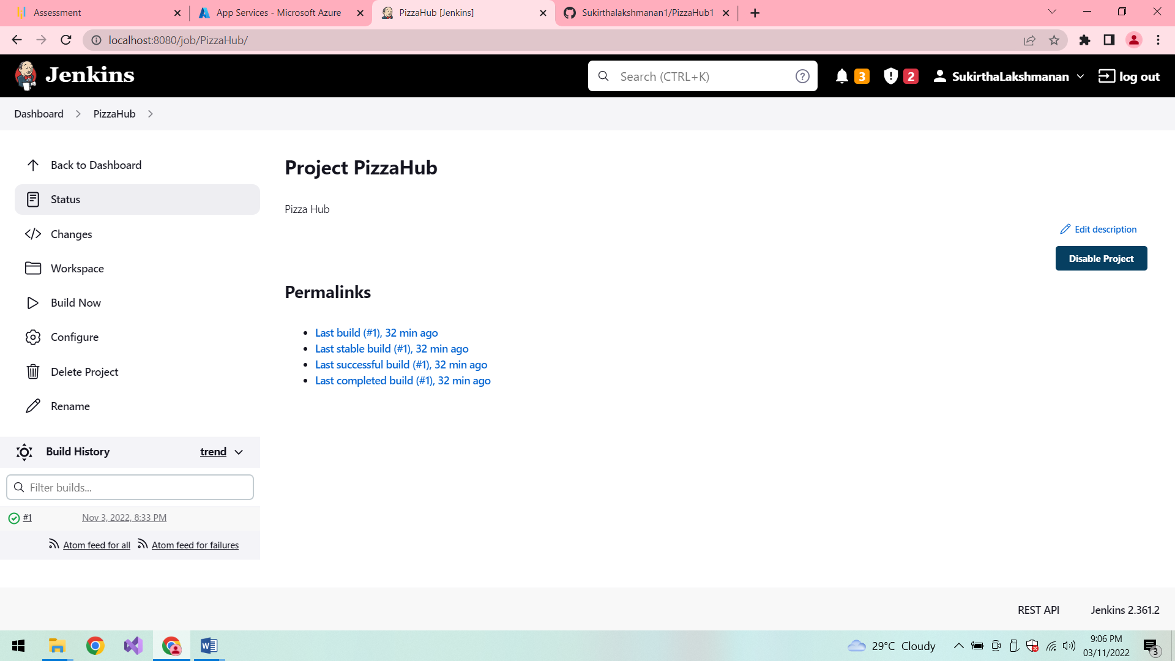

**Console Output:**

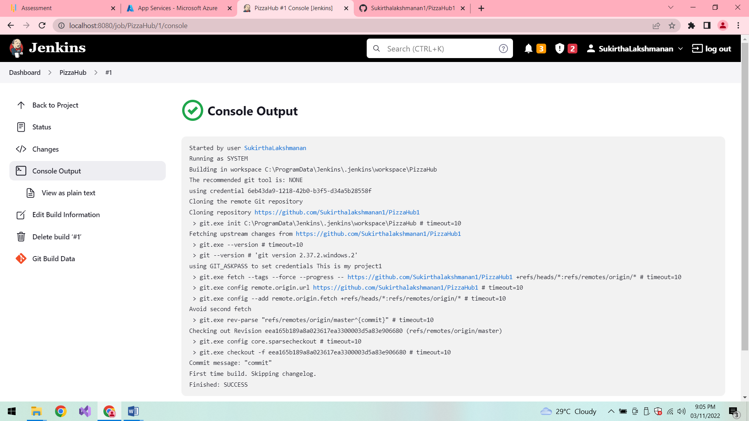

**Conclusion:**

Thus the application is developed successfully.